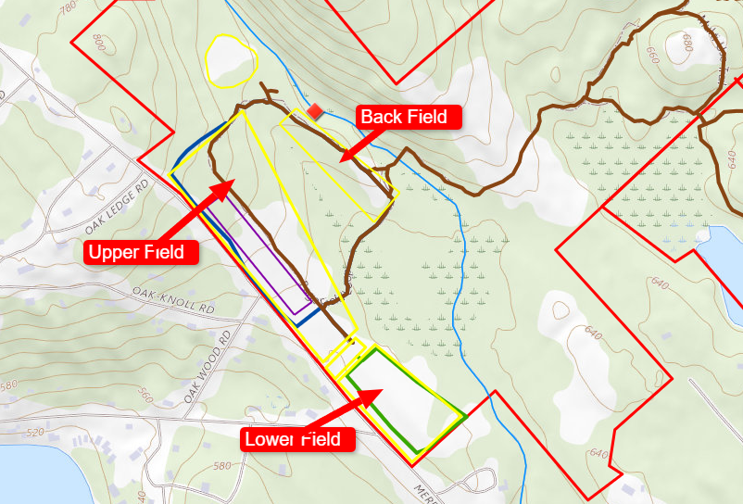2017
Purchased

2018
Brush hog autumn olive in upper field
First mowing of all fields
Cleared trees along Barnard Ridge Rd

2019
Mowed all fields
Master Plan defined
Located and marked boundaries
Built multi-purpose trail

2020
Mowed all fields

2021
Mowed all fields except lower 1/3 of upper field
A few olive trees sprouted in un-mowed area and were cut by hand

2022
Mowed all fields except middle 1/3 of upper field
A few olive trees sprouted in un-mowed area and were cut by hand
Bittersweet was but by hand around tree clumps (and apple trees)

2023
Mowed all fields
Treated invasives along stone walls, tree clumps (and apple trees)

